**ONLINE HOTEL RESERVATION PROJECT**

**CS 631 – Database Management System Design**

**Katie Perkins**

**Sudhan Rameshwaran**

**Yusuf Sabuwala**

**Phase 2 Goals**

In phase 2, we will design a relational database schema based on our conceptual schema design. We will focus on the logical database design step of the database design, which is also known as data model mapping. The relational model will be created from the enhanced ER (EER) schema which was created in Phase 1 of the project.

Revisions:

* Created entities: BReview, RReview, SReview.
* Deleted Entity Hotel Chain
* Deleted subclass Regular Price from Room
* The (Min, Max) relation of Hotel to Service is changed from (3,N) to (1,N)
* Attribute NoOfOrders added from Breakfast to Room_Res

**EER to Relational mapping**

Illustrate how you translated from the EER diagram to your Relational schema. It  
should follow the EER to Relational algorithm.  
  
**ER-to-Relational Mapping Algorithm**

Step 1: Mapping of Regular Entity Types  
Step 2: Mapping of Weak Entity Types  
Step 3: Mapping of Binary 1:1 Relation Types  
Step 4: Mapping of Binary 1:N Relationship Types.  
Step 5: Mapping of Binary M:N Relationship Types.  
Step 6: Mapping of Multivalued attributes.  
Step 7: Mapping of N-ary Relationship Types.

Mapping EER Model Constructs to Relations

Step 8: Options for Mapping Specialization or Generalization.

* Option 8A: Multiple Relations-Superclass and subclasses
* Option 8B: Multiple Relations-Subclass relations only
* Option 8C: Single relation with one type attribute
* Option 8D: Single relation with multiple type attributes

Step 9: Mapping of Union Types (Categories).

* Regarding OFFERROOM, we choose option 8A
* Regarding REVIEW with subclasses BREVIEW, RREVIEW, and SREVIEW we chose option 8B.

**Identify Difficulties** The slides from the professor helped to create the relational mapping for phase 2. The difficulties we faced were identifying the relations for superclass and subclass in regard to Review, and representing the ternary relationship between Customer, Credit card and Online Reservation.

**Relational Model**

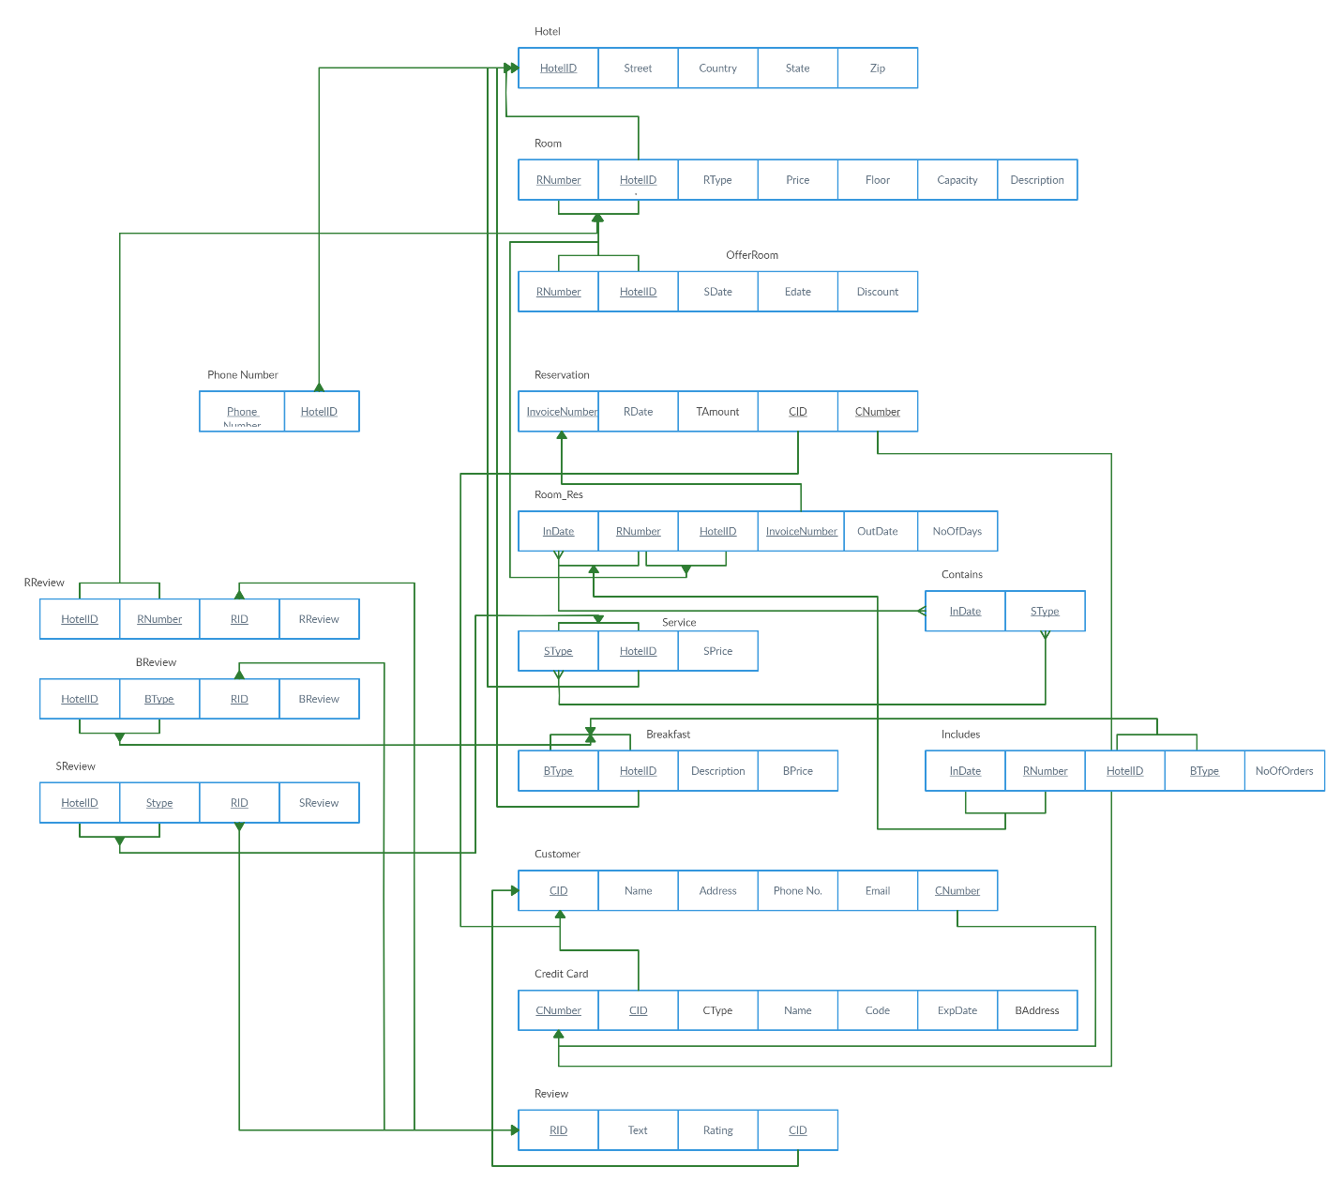

**Table List**

Phone Number

|  |  |
| --- | --- |
| HotelID | Phone Number |

Hotel

|  |  |  |  |  |
| --- | --- | --- | --- | --- |
| HotelID | Street | Country | State | Zip |

Room

|  |  |  |  |  |  |  |
| --- | --- | --- | --- | --- | --- | --- |
| RNumber | HotelID | RType | Price | Floor | Capacity | Description |

OfferRoom

|  |  |  |  |
| --- | --- | --- | --- |
| RNumber | SDate | EDate | Discount |

Reservation

|  |  |  |  |  |
| --- | --- | --- | --- | --- |
| InvoiceNumber | RDate | TAmount | CID | CNumber |

Room_Res

|  |  |  |  |  |
| --- | --- | --- | --- | --- |
| InDate | OutDate | NoOfDays | RNumber | InvoiceNumber |

Service

|  |  |  |
| --- | --- | --- |
| SType | SPrice | HotelID |

Contains

|  |  |
| --- | --- |
| InDate | SType |

Breakfast

|  |  |  |  |
| --- | --- | --- | --- |
| BType | Description | BPrice | HotelID |

Includes

|  |  |  |
| --- | --- | --- |
| InDate | BType | NoOfOrders |

Customer

|  |  |  |  |  |  |
| --- | --- | --- | --- | --- | --- |
| CID | Name | Address | Phone No. | Email | CNumber |

Credit Card

|  |  |  |  |  |  |  |
| --- | --- | --- | --- | --- | --- | --- |
| CNumber | CID | CType | Name | Code | ExpDate | BAddress |

Review

|  |  |  |  |
| --- | --- | --- | --- |
| RID | Text | Rating | CID |

RReview

|  |  |  |  |
| --- | --- | --- | --- |
| HotelID | RID | RNumber | RReview |

BReview

|  |  |  |  |
| --- | --- | --- | --- |
| HotelID | RID | BType | BReview |

SReview

|  |  |  |  |
| --- | --- | --- | --- |
| HotelID | RID | SType | RReview |

**Translated ER Diagram with Key Constraints**

CREATE TABLE Hotel_PhoneNo

(Phone_Number INTEGER,

HotelID INTEGER,

PRIMARY KEY (PhoneNo)

FOREIGN KEY (HotelID) references Hotel

ON DELETE SET NULL ON UPDATE CASCADE);

CREATE TABLE Hotel

(HotelID INTEGER,

Street VARCHAR(200),

Country VARCHAR(100),

State VARCHAR(2),

Zip VARCHAR(9),

PRIMARY KEY (HotelID)

ON DELETE SET NULL ON UPDATE CASCADE);

CREATE TABLE ROOM

(RNumber INTEGER,

HotelID INTEGER,

Rtype VARCHAR(100),

Price INTEGER,

Floor VARCHAR(4),

Capacity INTEGER,

PRIMARY KEY (RNumber)

FOREIGN KEY (HotelID) references HOTEL  
ON DELETE SET NULL ON UPDATE CASCADE);

CREATE TABLE OFFERROOM

(RNumber INTEGER,

SDate DATE,

RDate DATE,

Discount INTEGER,

FOREIGN KEY (RNumber) references ROOM

ON DELETE SET NULL ON UPDATE CASCADE);

CREATE TABLE_RESERVATION

(InvoiceNumber INTEGER,

CID INTEGER,

CNumber INTEGER,

RDate DATE,

TAmount INTEGER,

PRIMARY KEY (InvoiceNumber)

FOREIGN KEY (CID, CNumber) references CUSTOMER

ON DELETE SET NULL ON UPDATE CASCADE);

CREATE TABLE ROOM_RES

(InDate DATE,

OutDate DATE,

NoOfDays INTEGER,

InvoiceNumber INTEGER,

RNumber INTEGER,

PRIMARY KEY (InDate),

FOREIGN KEY (InvoiceNumber) references RESERVATION

FOREIGN KEY (RNumber) references ROOM

ON DELETE SET NULL ON UPDATE CASCADE);

CREATE TABLE SERVICE

(SType VARCHAR(50),

SPrice INTEGER,

HotelID INTEGER,

PRIMARY KEY (SType),

FOREIGN KEY (HotelID) references HOTEL

ON DELETE SET NULL ON UPDATE CASCADE);

CREATE TABLE CONTAINS

(SType VARCHAR(50),

InDate DATE,

FOREIGN KEY (SType) references SERVICE

FOREIGN KEY (InDate) references ROOM_RES

ON DELETE SET NULL ON UPDATE CASCADE);

CREATE TABLE BREAKFAST

(BType VARCHAR(50),

HotelID INTEGER,

BPrice INTEGER,

Description VARCHAR(150),

PRIMARY KEY (BType),

FOREIGN KEY (HotelID) references HOTEL

ON DELETE SET NULL ON UPDATE CASCADE);

CREATE TABLE INCLUDES

(NoOfOrders INTEGER,

InDate DATE,

BType VARCHAR(50),

FOREIGN KEY (InDate) references ROOM_RES,

FOREIGN KEY (BType) references BREAKFAST

ON DELETE SET NULL ON UPDATE CASCADE);

CREATE TABLE CUSTOMER

(CID INTEGER,

Name VARCHAR(20),

Address VARCHAR(100),

Phone No. INTEGER,

Email VARCHAR(30),

CNumber INTEGER,

PRIMARY KEY (CID),

FOREIGN KEY (CNumber) references CREDIT CARD,

ON DELETE SET NULL ON UPDATE CASCADE);

CREATE TABLE CREDIT CARD

(CNumber INTEGER,

CID INTEGER,

CType VARCHAR(10),

Name VARCHAR(20),

Code INTEGER,

ExpDate DATE,

BAddress VARCHAR(50),

PRIMARY KEY (CNumber),

FOREIGN KEY (CID) references CUSTOMER,

ON DELETE SET NULL ON UPDATE CASCADE);

CREATE TABLE REVIEW

(RID INTEGER,

Text VARCHAR(200),

Rating INTEGER,

CID INTEGER,

PRIMARY KEY (RID),

FOREIGN KEY (CID) references CUSTOMER,

ON DELETE SET NULL ON UPDATE CASCADE);

CREATE TABLE RReview

(HotelID INTEGER,

RNumber INTEGER,

RID INTEGER,

RReview VARCHAR(200),

FOREIGN KEY (RID) references REVIEW,

FOREIGN KEY (HotelID, RNumber) references ROOM,

ON DELETE SET NULL ON UPDATE CASCADE);

CREATE TABLE BReview

(HotelID INTEGER,

BType VARCHAR(50),

RID INTEGER,

BReview VARCHAR(200),

FOREIGN KEY (RID) references REVIEW,

FOREIGN KEY (HotelID, BType) references BREAKFAST,

ON DELETE SET NULL ON UPDATE CASCADE);

CREATE TABLE SReview

(HotelID INTEGER,

SType VARCHAR(50),

RID INTEGER,

SReview VARCHAR(200),

FOREIGN KEY (RID) references REVIEW,

FOREIGN KEY (HotelID, SType) references SERVICE,

ON DELETE SET NULL ON UPDATE CASCADE);